**STUDENTT NAME: GIELO MAR R. BANDOY  
COURSE/YR/SEC: BSCpE 3A  
SUBJECT: SOFTWARE DESIGN 2A  
DATE SUBMITTED: 03 – 22 – 2024**

**“CONNECTING API USING JAVASCRIPT IN VSCODE”**

**CODE:**

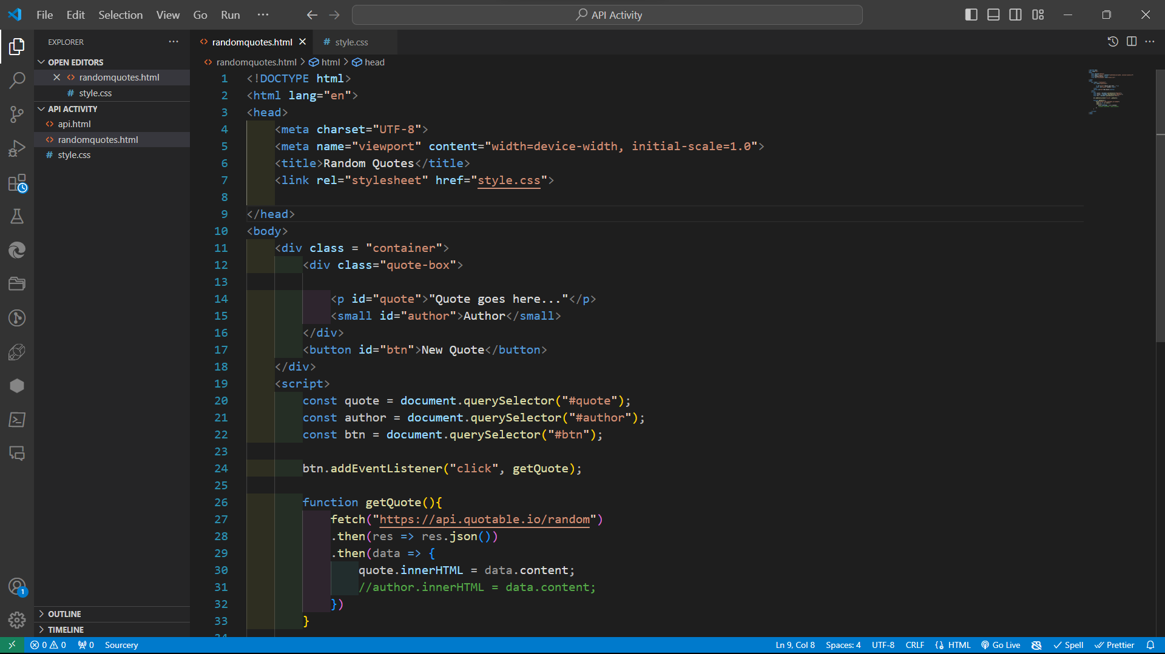

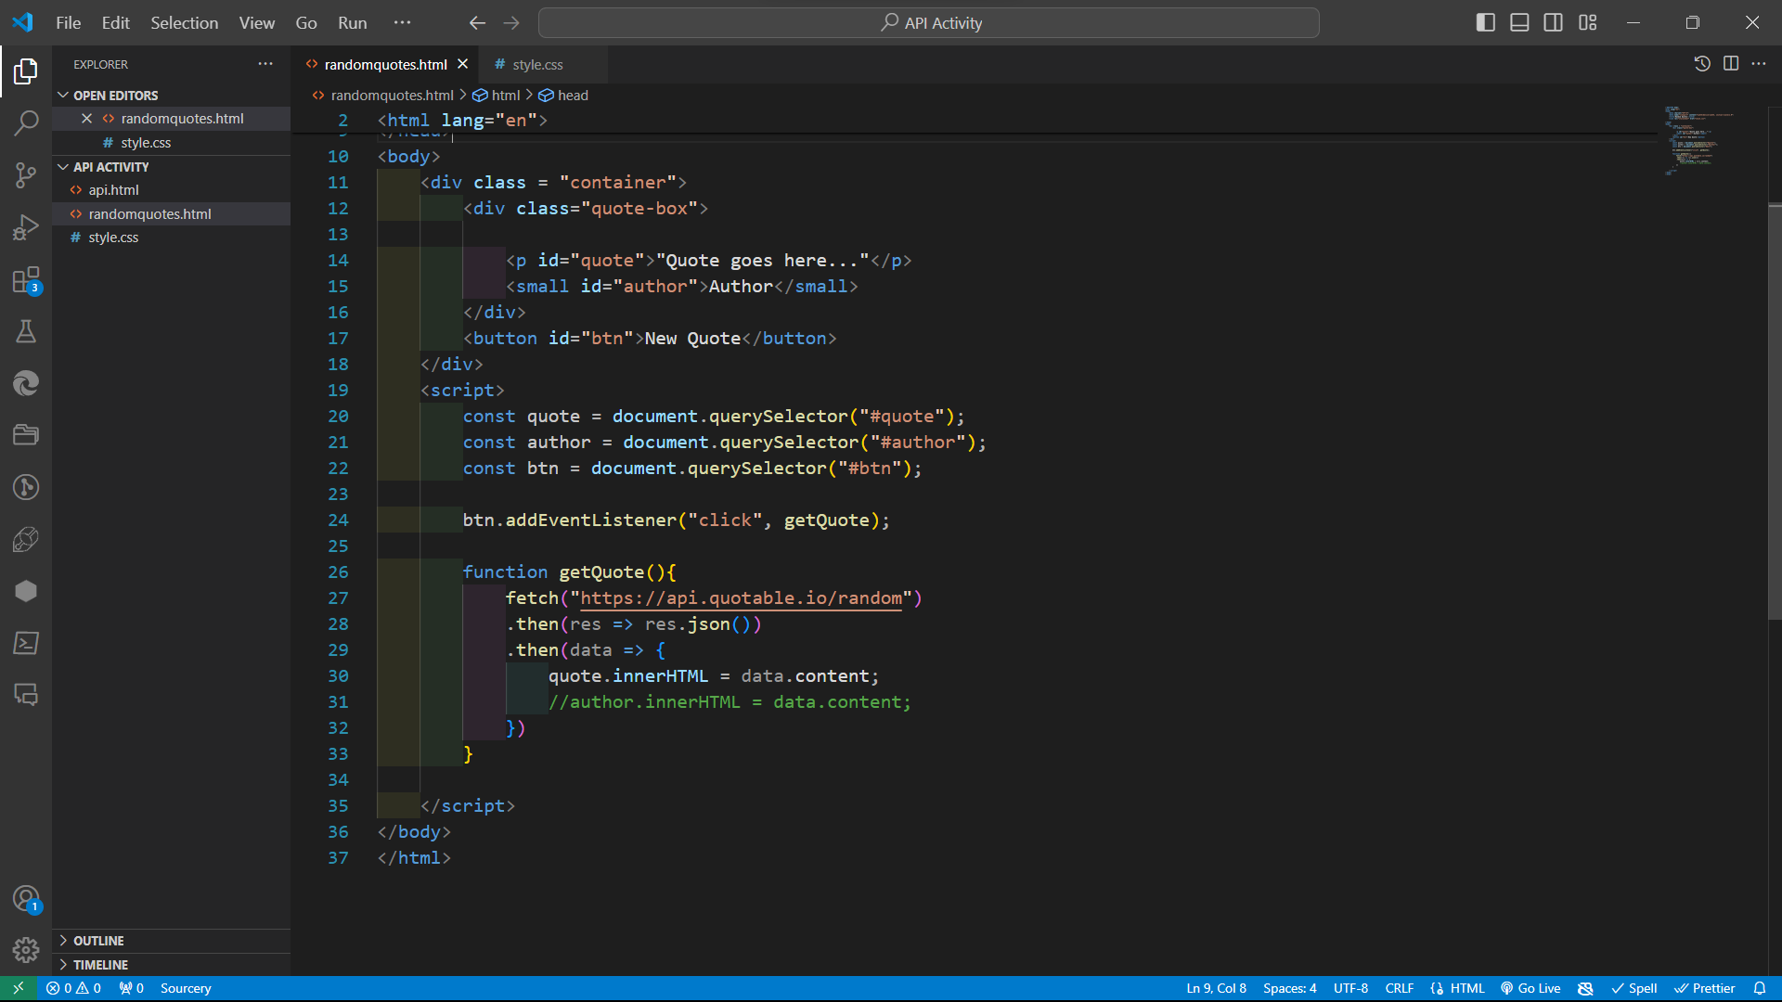

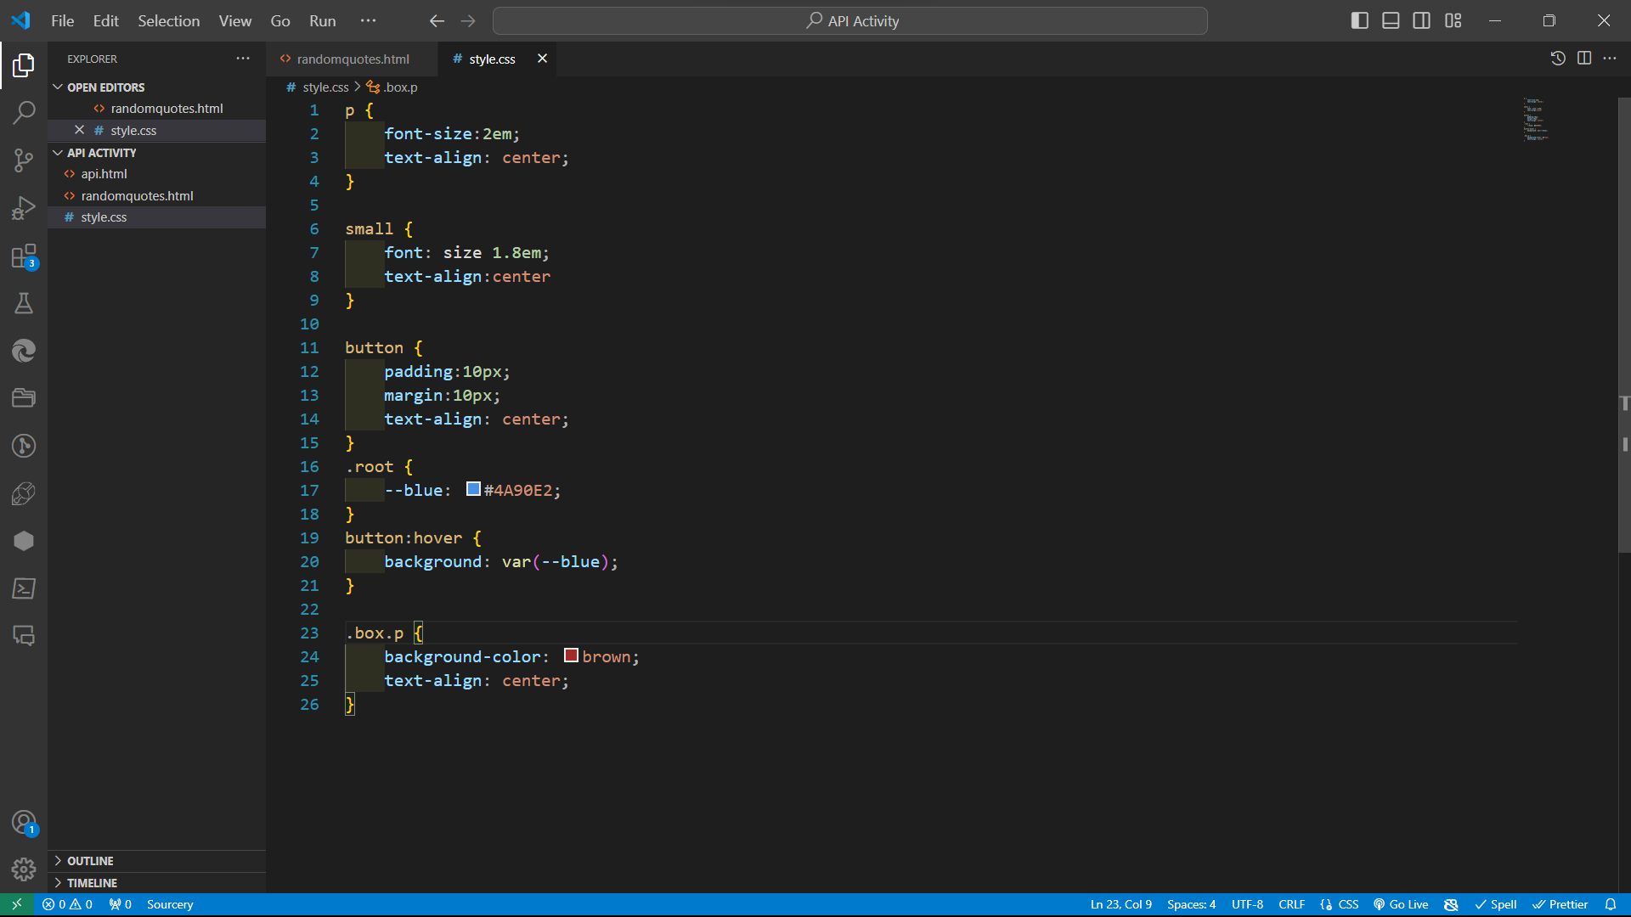

**OUTPUT:**

